**ABSTRACT**

The Organic Greens Management System (OGMS) is a robust solution aimed at enhancing the efficiency and sustainability of organic farming operations through the utilization of Database Management Systems (DBMS). In response to the escalating demand for organic produce, OGMS integrates various functionalities essential for streamlined agricultural management, including crop planning, inventory control, resource allocation, sales tracking, and analytics.DBMS serves as the cornerstone of OGMS, enabling the centralized storage, organization, and retrieval of vast amounts of agricultural data. Leveraging relational database principles, OGMS ensures data integrity and facilitates seamless interaction between different data entities, empowering farmers and agricultural professionals with valuable insights and decision-making capabilities.By harnessing the power of DBMS, OGMS facilitates seamless data management and analysis, ultimately contributing to the optimization of organic farming practices. This abstract provides an overview of the Organic Greens Management System, emphasizing its reliance on DBMS to streamline agricultural operations and drive sustainable growth in the organic farming sector.

**TABLE OF CONTENTS**

Chapter 1 Introduction

1.1 Motivation and Scope

1.2 Introduction

1.3 Core Concept

1.4 Limitations

Chapter 2 Requirements and System Analysis

2.1 Functional Requirements

2.2 Non-Functional Requirements

Chapter 3 System Specifications

3.1 Software Specifications

3.2 Hardware Specifications

Chapter 4 Analysis and Design

4.1 ER Diagram

4.2 Schema Diagram

Chapter 5 Implementation

5.1 Source Code along with documentation

Chapter 6 Testing

Interpretation of Results

Conclusion

References

**CHAPTER 1**

**Introduction**

# 1.1 Motivation and Scope

Developing a management system for selling organic greens using a Database Management System (DBMS) can be a highly rewarding project with significant potential. There's a growing demand for organic products, including organic greens, due to increasing health awareness and environmental concerns. This trend presents a lucrative market opportunity for businesses involved in selling organic produce. Managing sales, inventory, customer data, and other aspects manually can be cumbersome and prone to errors. A well-designed management system can scale with the business, accommodating growth seamlessly.By capturing and analyzing data related to sales, customer preferences, inventory levels, and more, the system can provide valuable insights that inform business decisions and strategies. A robust management system can improve the overall customer experience by enabling smoother transactions, personalized recommendations, and efficient order fulfillment.The scope of the system includes inventory management to track the availability of various organic greens, sales management to record transactions and generate invoices, customer management to maintain a database of customer information and preferences, and order processing to facilitate the placement and fulfillment of orders. User authentication and authorization mechanisms ensure that only authorized personnel can access and modify sensitive data. Integration with other systems or platforms, such as e-commerce websites or payment gateways, enhances functionality. A user-friendly interface, robust security measures, and scalability considerations are also integral parts of the system's scope.Incorporating feedback mechanisms for continuous improvement and compliance with relevant regulations, such as GDPR or CCPA, further enhance the system's value and utility. Overall, by addressing these aspects within the scope of your DBMS-based organic greens selling management system, you can create a valuable tool that streamlines operations and contributes to the success and growth of your organic produce business.

# 1.2 Problem Statement

As the demand for organic produce continues to rise due to increased health consciousness and environmental concerns, there is a growing need for efficient management systems to handle the complexities of selling organic greens. To address this demand, we propose the development of an Organic Greens Selling Management System using Database Management Systems (DBMS).The system aims to streamline the processes involved in the selling of organic greens, including inventory management, sales tracking, customer management, and supplier management. The primary objective is to provide a comprehensive solution that enables businesses in the organic greens industry to operate more effectively and efficiently.

# 1.3 Core Concept

Developing a management system for selling organic greens involves several core concepts that can be implemented using a Database Management System (DBMS) to efficiently organize and manage the business processes. Here are some key components and concepts:**Data Model Design**

Designing an appropriate data model is crucial. This involves identifying entities (such as customers, products, orders), their attributes, and the relationships between them. For example: - Entity: Customer, Attributes: Name, Address, Phone Number, etc. - Entity: Product, Attributes: Name, Description, Price, etc. - Entity: Order, Attributes: Order ID, Customer ID (foreign key), Product ID (foreign key), Quantity, Total Price, etc.**Inventory Management**

Track inventory levels of organic greens to ensure availability for customers and prevent overstocking or stockouts. The database should maintain real-time information about quantities of different greens available, their expiration dates, and any other relevant details.**Sales Management**

Manage sales transactions including order placement, payment processing, and order fulfillment. This involves recording orders, updating inventory levels upon order placement, generating invoices, and tracking payment status.

**Cutomer Relationship Management (CRM)**

Maintain customer information and interactions to enhance customer satisfaction and retention. This includes storing customer details, purchase history, preferences, and feedback.**Supplier Management**

Keep track of suppliers providing organic greens. This involves maintaining information about suppliers, their contact details, products supplied, pricing, and delivery schedules.**Price Management**

Manage pricing strategies for organic greens based on factors such as market demand, seasonality, and supplier costs. The system should allow for flexible pricing and discounts.**Reporting and Analytics**

Implement reporting features to analyze sales trends, inventory turnover, customer behavior, and profitability. This helps in making data-driven decisions for business growth and optimization.**User Authentication and Authorization**

Implement security measures to control access to the system. Different user roles may include administrators, sales staff, and managers, each with varying levels of access rights.**Integration with External Systems**

Integrate with external systems such as payment gateways for online transactions, accounting software for financial management, and suppliers' systems for seamless ordering and inventory management.**Scalability and Performance**

Design the database schema and queries to ensure scalability as the business grows. Optimize performance by indexing frequently accessed data, tuning queries, and implementing caching mechanisms.

# 1.4 Limitations

Organic greens selling management systems using database management systems (DBMS) offer several advantages, including efficient data storage, retrieval, and management. However, they also come with some limitations:**Scalability**

While DBMS can handle large amounts of data, scaling up can become challenging, especially if the system experiences rapid growth or if the database schema needs frequent modifications.**Complexity of Queries**

As the system grows and becomes more complex, constructing queries to extract specific information can become increasingly difficult and time-consuming. This complexity can hinder the system's performance and efficiency.**Data Integrity**

Ensuring data integrity within the database is crucial, particularly in systems handling financial transactions or sensitive customer information. Despite built-in mechanisms such as constraints and transactions, maintaining data integrity can be challenging and require constant vigilance.**Security Concerns**

Storing sensitive information in a database introduces security risks, including unauthorized access, data breaches, and cyberattacks. Implementing robust security measures such as encryption, access controls, and regular audits is essential but can be resource-intensive.**Performance Issues**

As the volume of data increases, performance issues such as slow query execution and database latency may arise. Optimizing queries, indexing frequently accessed data, and periodically tuning the database can help mitigate these issues, but they require ongoing monitoring and maintenance.**Cost of Implementation and Maintenance**

Developing and maintaining a DBMS-based system can be costly, requiring investment in hardware, software licenses, skilled personnel, and ongoing support and maintenance. Additionally, the cost may increase as the system grows and evolves over time.**Vendor Lock-in**

Depending on the choice of DBMS vendor, the organization may become locked into a specific technology stack, making it difficult and costly to migrate to alternative solutions in the future.**Data Redundancy and Inconsistency**

Without proper normalization and data modeling, redundant data storage and inconsistency across the database can occur, leading to inefficiencies and inaccuracies in reporting and decision-making.**Dependency on Technical Expertise**

Managing a DBMS-based system requires specialized technical expertise in database administration, data modeling, and query optimization. Organizations may face challenges in recruiting and retaining qualified personnel to maintain and support the system effectively.**Integration Complexity**

Integrating the DBMS with other systems or third-party applications can be complex and time-consuming, particularly if they use different data formats or communication protocols. Ensuring seamless integration while preserving data integrity and security requires careful planning and implementation.

**CHAPTER 2**

**Requirements and System Analysis**

# 2.1 Functional Requirements

Functional requirements for an organic greens selling management system using a Database Management System (DBMS) would involve various aspects of managing inventory, sales, customer information, and possibly more. Here's a list of functional requirements that such a system might need:**User Authentication and Authorization:**  - Users should be able to register and log in with different roles (e.g., admin, staff, customer). - Admin should have access to all functionalities, while staff might have restricted access.**Product Management:** - Ability to add, edit, and delete organic greens products. - Each product should have attributes such as name, description, price, quantity, and category (e.g., lettuce, kale, spinach). - Capability to track inventory levels and receive alerts for low stock.**Order Management:** - Customers should be able to browse products, add them to a shopping cart, and place orders. - Staff should be able to view and process orders, mark them as fulfilled, and update order status. - Generate invoices or receipts for orders.**Inventory Management:** - Track stock levels in real-time. - Automatic deduction of stock upon order placement. - Restocking functionality for staff to add new inventory.**Customer Management:** - Maintain a database of customer information, including name, contact details, and order history. - Allow customers to view their past orders and reorder items.**Payment Integration:** - Integration with payment gateways for online payments. - Support for multiple payment methods (e.g., credit/debit cards, PayPal).**Reporting and Analytics:** - Generate reports on sales, revenue, popular products, etc. - Provide insights into customer behavior and preferences. - Analyze trends over time to make informed business decisions.**Search and Filtering:** - Enable customers to search for products by name, category, or attributes. - Allow filtering of products based on various criteria (e.g., price range, organic certification).**Promotions and Discounts:** - Ability to apply discounts or promotions to products. - Support for promotional codes and coupons.**Shipping and Delivery:** - Capture shipping information during checkout. - Integration with shipping carriers for real-time shipping rates and tracking. - Notify customers about order status and tracking information.**Feedback and Reviews:** - Allow customers to leave reviews and ratings for products. - Provide a mechanism for customers to give feedback on their shopping experience.**System Administration:** - Ability for admin users to manage system settings, such as tax rates, shipping options, etc. - Backup and restore functionality to prevent data loss.These are some of the functional requirements for an organic greens selling management system using a DBMS. The system should also be scalable, secure, and user-friendly to ensure smooth operations and customer satisfaction.

# 2.2 Non-Functional Requirements

Non-functional requirements for an organic greens selling management system using a database management system (DBMS) encompass various aspects related to the system's performance, usability, security, reliability, and other key characteristics. Here are some non-functional requirements specific to this system:**Performance:** - The system should be capable of handling concurrent user requests efficiently, especially during peak hours. - Response time for common operations such as adding products, processing orders, and generating reports should be minimal, typically within a few seconds. - The system should be scalable to accommodate increasing data volume and user load over time.Usability

-The user interface should be intuitive and easy to navigate, catering to users with varying levels of technical expertise. - Support for multiple languages and accessibility features such as screen readers should be included to ensure usability for all users. - The system should provide helpful error messages and clear instructions to assist users in resolving issues.**Security:**

- Access to sensitive data such as customer information, sales records, and inventory data should be restricted based on user roles and permissions. - Data transmission between the client and server should be encrypted using secure protocols (e.g., HTTPS) to prevent unauthorized access or interception. - The system should implement measures to protect against common security threats such as SQL injection, cross-site scripting (XSS), and cross-site request forgery (CSRF).**Reliability:**

- The system should have a high level of availability, with minimal downtime for maintenance or upgrades. - Automated backup and recovery procedures should be implemented to ensure data integrity and minimize the risk of data loss in case of system failures. - The system should be capable of handling errors gracefully, providing informative error messages and preserving data integrity in case of unexpected events.**Scalability:**  - The system architecture should be designed to scale horizontally and vertically to accommodate growth in data volume and user traffic. - Load balancing mechanisms should be employed to distribute incoming requests evenly across multiple server instances, ensuring optimal performance under varying load conditions. - Database schema should be optimized for scalability, with efficient indexing and partitioning strategies to support large datasets without sacrificing performance.**Compatibility:** - The system should be compatible with a wide range of devices and operating systems, including desktops, laptops, tablets, and smartphones. - Support for popular web browsers such as Chrome, Firefox, Safari, and Edge should be ensured to maximize accessibility for users.**Maintainability:** - The system should be modular and well-documented, facilitating ease of maintenance and future enhancements. - Code versioning and deployment automation tools should be utilized to streamline the software development lifecycle and minimize deployment errors.By addressing these non-functional requirements, the organic greens selling management system can deliver a robust, secure, and user-friendly experience to its stakeholders while ensuring scalability and maintainability for future growth and enhancements.

**CHAPTER 3**

**System Specifications**

The software specifications for the organic greens selling management system encompass requirements for operating systems, programming languages, frameworks, database management systems, development tools, security measures, testing frameworks, deployment tools, monitoring solutions, backup and recovery mechanisms, and documentation tools. Similarly, hardware specifications involve considerations such as server hardware, networking infrastructure, client devices, power supply, cooling systems, scalability, and budget constraints, all aimed at providing optimal performance, reliability, and scalability for the system's operations. Thorough analysis and consultation with IT professionals are crucial for determining the most suitable software and hardware configurations to support the management system effectively.

# 3.1 Software specifications

Software requirements for an organic greens selling management system using a database management system (DBMS) typically encompass both functional and non-functional aspects. Here's a list of software requirements for such a system:**Operating System:** The system should be compatible with popular operating systems such as Windows, macOS, and Linux distributions.**Web Server:** The system may require a web server software such as Apache HTTP Server, Nginx, or Microsoft Internet Information Services (IIS) to host the web application.**Programming Languages and Frameworks:**

- Backend: Choose a suitable programming language such as Python, Java, PHP, or Node.js for server-side development. - Frameworks: Select appropriate frameworks such as Django, Spring Boot, Laravel, or Express.js to expedite development and provide essential functionalities. - Frontend: Utilize HTML, CSS, and JavaScript frameworks/libraries like React, Angular, or Vue.js for building the user interface.**Database Management System (DBMS):** - Choose a relational DBMS such as MySQL, PostgreSQL, Microsoft SQL Server, or Oracle Database to store and manage data related to products, orders, customers, etc. - Alternatively, consider using a NoSQL database like MongoDB if the data structure is more flexible or if there's a need for scalability.**Development Tools:** - Integrated Development Environment (IDE): Use IDEs like Visual Studio Code, PyCharm, Eclipse, or IntelliJ IDEA for efficient coding and debugging. - Version Control: Employ version control systems like Git along with platforms such as GitHub, GitLab, or Bitbucket for collaborative development, code management, and tracking changes. - Dependency Management: Use package managers like npm (Node.js), pip (Python), Maven (Java), or Composer (PHP) to manage project dependencies and libraries.Security Tools: - Utilize security tools and libraries to implement authentication, authorization, data encryption, and protection against common security vulnerabilities such as SQL injection, XSS, CSRF, etc. - Implement HTTPS encryption for secure data transmission over the network.**Testing Frameworks:** - Choose testing frameworks such as pytest, JUnit, PHPUnit, or Jasmine for writing and executing unit tests, integration tests, and end-to-end tests to ensure the system's reliability and correctness.**Deployment Tools:** - Use deployment automation tools like Docker, Kubernetes, or Ansible for containerization, orchestration, and efficient deployment of the system across different environments (development, testing, production).**Monitoring and Logging:** - Implement logging frameworks like Log4j, Logback, or Winston for logging system events, errors, and debugging information. - Utilize monitoring tools like Prometheus, Grafana, or ELK Stack (Elasticsearch, Logstash, Kibana) for real-time monitoring, performance analysis, and log aggregation.**Backup and Recovery:** - Set up backup and recovery mechanisms to regularly backup the database and system configuration, ensuring data integrity and resilience against data loss due to hardware failures, disasters, or human errors.**Documentation Tools:** - Use documentation tools such as Swagger/OpenAPI for API documentation, README files, and internal documentation to facilitate understanding, usage, and maintenance of the system.By fulfilling these software requirements, the organic greens selling management system can be developed, deployed, and maintained effectively, meeting the needs of its users while ensuring scalability, security, and reliability.

# 3.2 Hardware specifications

Designing a hardware setup for an organic greens selling management system using a Database Management System (DBMS) involves considering factors such as the scale of operations, concurrent users, data volume, and performance requirements. Here's a general outline of hardware specifications:

**Server:**

- Processor: Multi-core processor (e.g., Intel Xeon, AMD Ryzen) for handling simultaneous requests efficiently.

- RAM: Depending on the scale of operations and concurrent users, at least 16GB to 64GB or more of RAM for optimal performance.

- Storage: SSD (Solid State Drive) for faster data access, with sufficient capacity to store the database, operating system, and other software components. The size depends on the expected data volume and growth rate.

- Network Interface: Gigabit Ethernet for fast network connectivity.

- Redundancy: Consider implementing RAID (Redundant Array of Independent Disks) for data redundancy and fault tolerance.

**Networking:**

- Switches and routers capable of handling the network traffic between client devices and the server.

- Consider network security measures such as firewalls and intrusion detection/prevention systems.

**Client Devices:**

- Desktops, laptops, or mobile devices for accessing the management system.

- Ensure compatibility with the software requirements and provide adequate resources for running web browsers or dedicated client applications.

**Power Supply:**

- Uninterruptible Power Supply (UPS) to protect the server from power outages and ensure continuous operation.

**Cooling and Ventilation:**

- Adequate cooling systems to maintain optimal operating temperatures for the server hardware.

Scalability:

- Design the hardware setup with scalability in mind, allowing for easy expansion as the business grows.

- Consider clustering or distributed systems architecture for handling increased loads in the future.

Budget Considerations:

- Balance hardware specifications with budget constraints, prioritizing critical components like CPU, RAM, and storage.

It's essential to conduct a thorough analysis of your requirements, considering factors such as the expected number of concurrent users, transaction volume, data growth rate, and budget constraints, to determine the most suitable hardware configuration for your organic greens selling management system. Additionally, consulting with a professional IT architect or system administrator can help ensure that your hardware setup meets your specific needs effectively.

**CHAPTER 4**

**Analysis and Design**

## 4.1 ER Diagram:

A ER diagram for the Organic Greens Management System (OGMS) visually represents the various interactions and functionalities of the system from the perspective of its users.

4.1 ER Diagram-Organic Greens Management System

## 4.2 Schema diagram

.

4.2 Schema diagram,

**CHAPTER 5**

**Implementation**

The implementation phase of your terminal-based Organic Greens Management System involves turning the system design and requirements into a fully functional software application.

**5.1 Description of Frameworks Used**

Integration of frontend frameworks such as HTML, CSS and JavaScript for creating an intuitive user interface.

* HTML forms the structure of web pages, defining the layout and content hierarchy.
* Utilize semantic HTML5 elements for better accessibility and search engine optimization.
* CSS is used for styling HTML elements, enhancing the visual appeal and user experience.
* JavaScript adds interactivity to web pages, facilitating dynamic content updates and user-driven actions.

Utilization of XAMPP and PHP for backend support, enabling efficient implementation of profile management and recommendation functionalities. Description of recommendation algorithm implementation, including data preprocessing and model training techniques.

* XAMPP simplifies the setup of a local development environment, MySQL database, and PHP interpreter.
* Utilize XAMPP for rapid prototyping and testing of backend functionalities before deployment.
* PHP is a server-side scripting language used for backend development in web applications.
* Leverage PHP's extensive library of functions for database interaction, file handling, and session management.

**5.2 Description of Integrated Development Environment**

Configuration of IDE for efficient development and debugging of frontend and backend components. Utilization of frontend development tools for responsive design and cross-browser compatibility.

Use of version control systems for collaborative development and tracking of code changes. Additionally, incorporating browser developer tools like Chrome DevTools or Firefox Developer Tools allows developers to inspect and debug frontend code directly within the browser, aiding in the creation of responsive designs and ensuring cross-browser compatibility.

Utilization of frontend development tools, and adoption of version control systems are essential practices for enhancing the efficiency, collaboration, and maintainability of software projects. By leveraging these technologies and best practices, developers can streamline their workflows, produce high-quality code, and deliver robust frontend and backend components that meet the demands of modern web development.

**CHAPTER 6**

**Testing**

## Requirements Analysis

Review the system requirements and specifications to understand what the system is expected to do.

## Test Planning

Create a detailed test plan that includes objectives, scope, test cases, testing resources, and a timeline.

## Test Environment Setup

Set up a testing environment that mirrors the production environment as closely as possible. This includes database configurations, server setups, and necessary software.

Test Types

Identify the types of testing needed:

**Functional Testing:** Ensure all functions of the system work correctly.

**Performance Testing:** Assess system responsiveness, scalability, and load handling.

**Security Testing:** Verify data protection and system security.

**Usability Testing:** Evaluate the system's user-friendliness.

**CHAPTER 7**

**Interpretation of Results**

The farm assistance web server, built using HTML, CSS, JavaScript, and PHP, serves as a platform for farmers to list and sell their products directly to customers without the need for third-party intermediaries. This innovative solution aims to streamline the agricultural supply chain, empowering farmers to connect directly with consumers and enhance their market access. Through intuitive web interfaces and efficient backend functionalities, the platform facilitates seamless transactions and fosters greater transparency in the agricultural marketplace.

The results of the farm assistance web server implementation signify significant benefits for both farmers and consumers:

**Empowerment of Farmers:**

* Farmers can easily list the products they have grown on the platform, providing detailed information such as product type, quantity, and pricing.
* The direct-to-consumer model eliminates the need for intermediaries, allowing farmers to retain a larger share of the profits from their sales.
* Real-time updates and notifications enable farmers to manage inventory effectively and respond promptly to customer inquiries and orders.

**Enhanced Market Access:**

* By showcasing their products on an accessible online platform, farmers can reach a wider audience beyond their local markets.
* Consumers have access to a diverse range of fresh, locally sourced produce directly from the farmers, promoting sustainability and supporting local agriculture.
* The platform facilitates transparent communication between farmers and consumers, fostering trust and loyalty within the agricultural community.

**Streamlined Transactions:**

* The user-friendly interface allows customers to browse products, add items to their cart, and complete transactions seamlessly.
* Integration of secure payment gateways ensures the confidentiality and integrity of financial transactions, enhancing customer confidence in the platform.
* Automated order processing and shipment tracking functionalities streamline the fulfillment process, ensuring timely delivery of products to customers.

**Data-driven Insights:**

* Backend analytics tools provide valuable insights into consumer preferences, market trends, and sales performance.
* Farmers can leverage these insights to optimize their product offerings, pricing strategies, and marketing efforts, thereby maximizing profitability and competitiveness.
* Continuous monitoring and analysis of user interactions enable ongoing refinement and improvement of the platform's features and functionalities.

Fig 7.1 depicts the homepage of the website, featuring a sleek and user-friendly interface designed to engage visitors at first glance. The combination of vibrant visuals and intuitive navigation ensures an inviting user experience, encouraging exploration of the site's content.

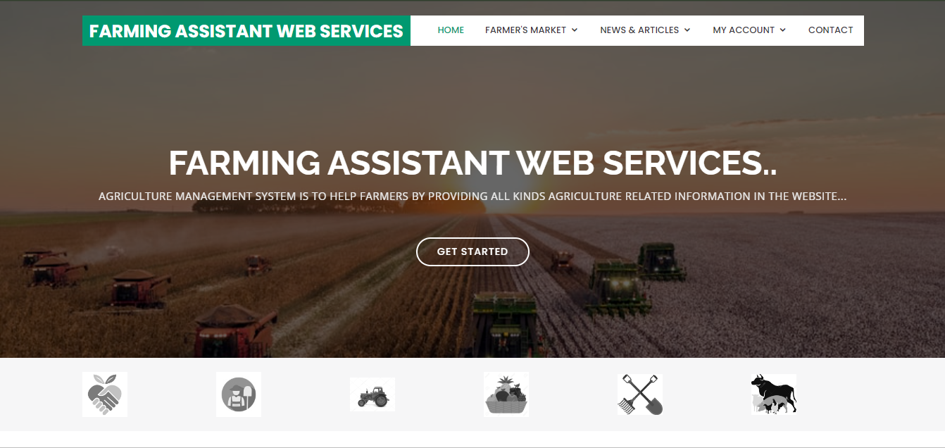

**Fig 7.1 home page**

Figure 7.3 depicts the Farmer’s Market section, presenting a variety of products added by farmers. Users can easily browse and add these products to their cart for purchase, facilitating a seamless shopping experience on the platform.

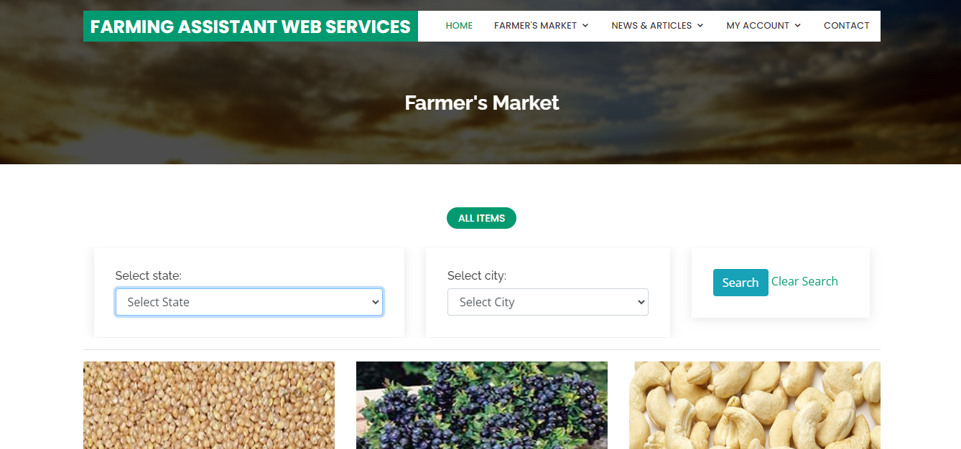

**Fig 7.3 Farmer’s Market**

Fig 7.4.1 includes a dedicated section for news, featuring updates on government schemes aimed at supporting agricultural development. In Fig 7.4.2 users can access articles containing relevant content from newspapers, providing valuable insights and information for farmers and stakeholders in the agriculture sector.



**Fig 7.4.1: News Section**

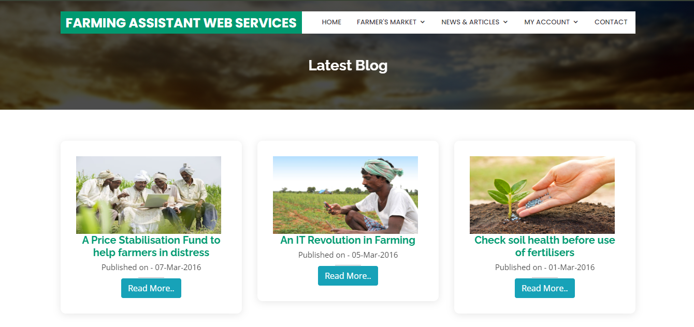

**Fig 7.4.2: Articles**

Figures 7.5.1, 7.5.2, and 7.5.3 respectively depict the Customer, Farmers, and Staff login interfaces, each tailored to their specific roles. These login pages provide secure access to the platform's functionalities, allowing users to authenticate and access personalized features based on their designated roles as customers, farmers, or staff members.

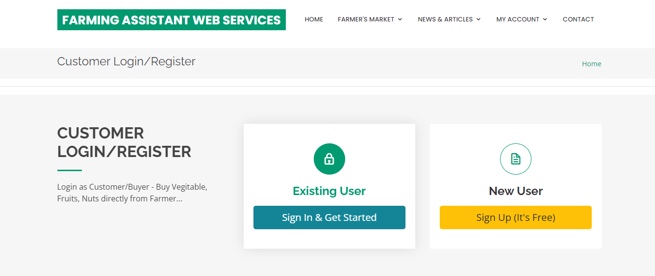

**Fig 7.5.1: Customer Login**

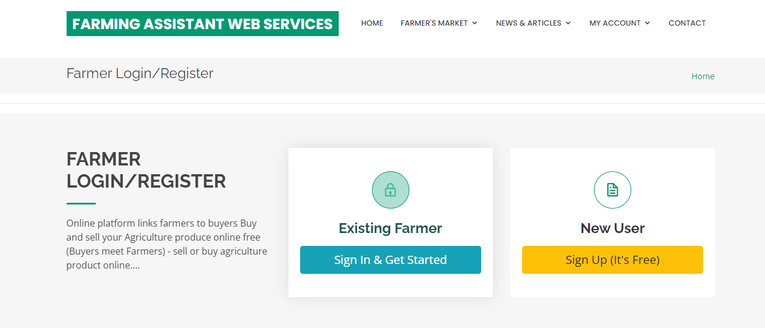

**Fig 7.5.2: Farmers Login**

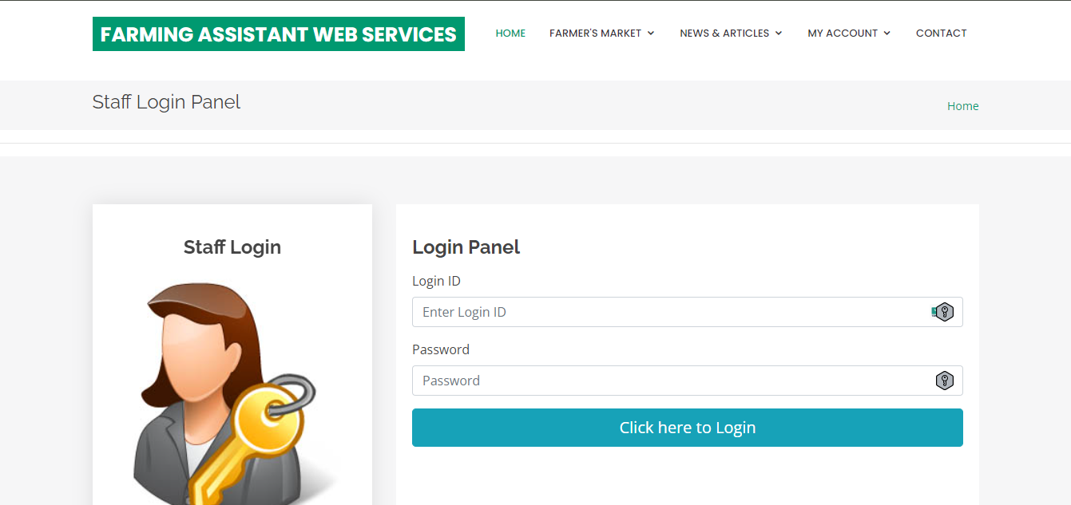

**Fig 7.5.3 Staff Login**

Figure 7.6 showcases the "Contact Us" page, offering users a convenient means to reach out for support or inquiries.

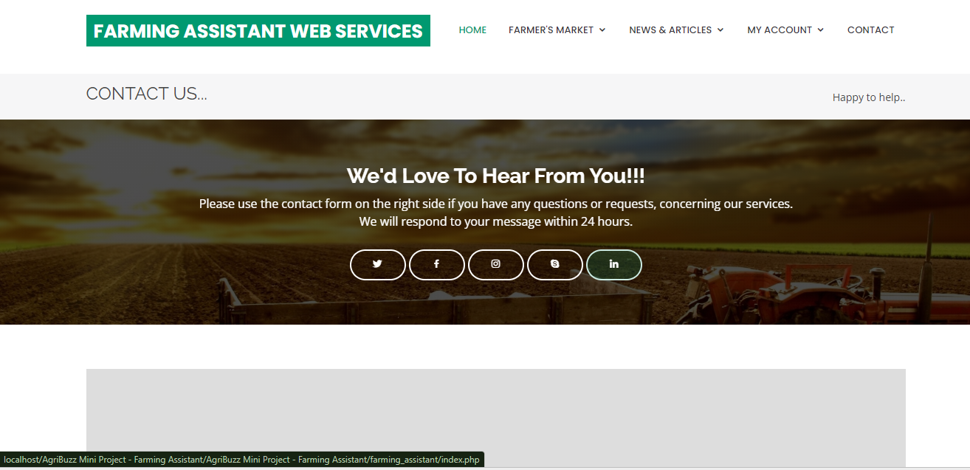

**Fig 7.6 Contact Us**

Fig 7.7 provides essential navigation links and contact information, enhancing user accessibility and facilitating communication.

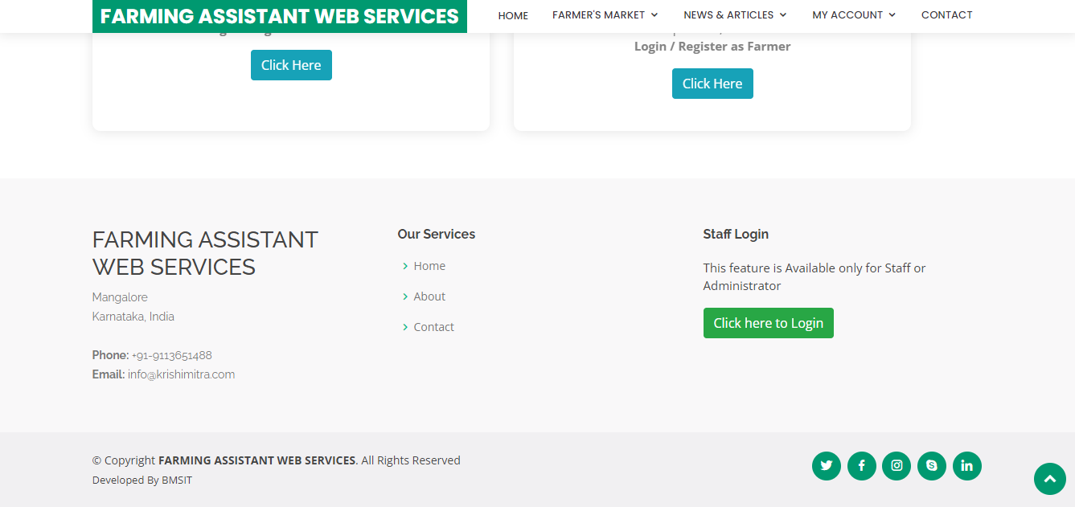

**Fig 7.7:Footer**

PhpMyAdmin is a web-based tool for managing MySQL databases, allowing users to create, edit, and manipulate database tables efficiently through a user-friendly interface.

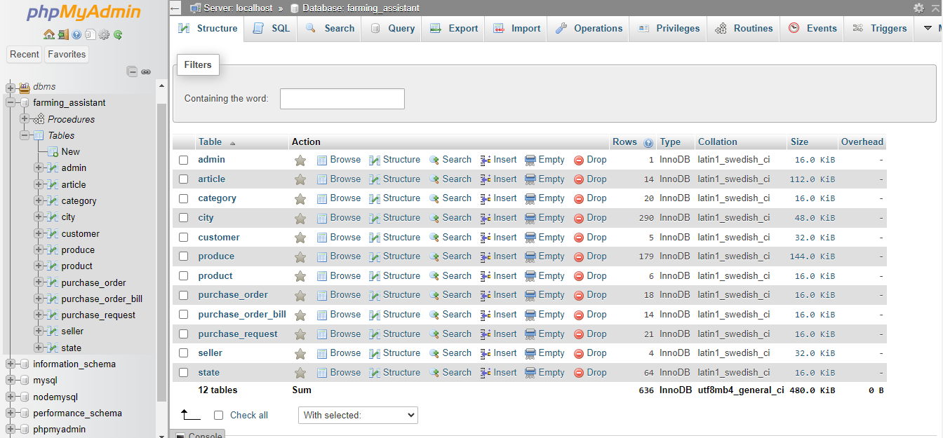

**Fig 7.8 PhpMyAdmin Table**

**Conclusion**

The development of an Organic Greens Selling Management System using a Database Management System (DBMS) offers numerous advantages for both the sellers and consumers in the organic produce market. Through the implementation of this system, various processes such as inventory management, sales tracking, customer relations, and supply chain management can be efficiently streamlined, enhancing overall productivity and profitability.The utilization of a DBMS provides a robust platform for storing, managing, and retrieving data related to organic greens, ensuring data integrity, security, and scalability. By leveraging features such as relational database structure, queries, and transaction management, the system facilitates seamless communication and coordination across different departments within the organization.Furthermore, integrating functionalities such as online ordering, payment processing, and delivery tracking enhances the customer experience, making it more convenient for them to access organic greens while promoting sales growth and customer loyalty. The system also enables sellers to analyze market trends, track product preferences, and optimize pricing strategies based on real-time data insights, thereby enhancing competitiveness in the market.

**References**

1.GEEKS FOR GEEKS:<https://www.geeksforgeeks.org/java/>

2.W3SCHOOLS:<https://www.w3schools.com/java/java_oop.asp>

3.JAVATPOINTS:<https://www.javatpoint.com/student-management-system>

4[.https://www.w3resource.com/jav](https://www.w3resource.com/java)[a-exercises/oop/java-oop-exercise-6.php](https://www.w3resource.com/java-exercises/oop/java-oop-exercise-6.php)

5. https://itsourcecode.com/free-projects/java-projects/employee-management-system-project-

injava-with-source-code/